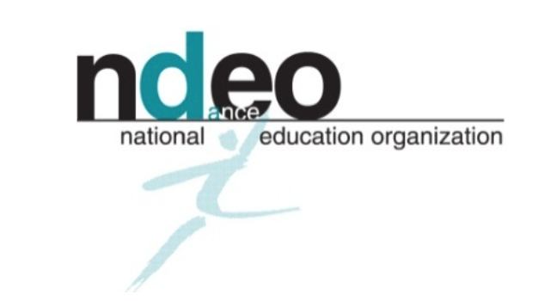

Workshop Proposal

Date:

NDEO Member Nominating Workshop:

Title of Workshop:

Name of Instructor:
Brief Bio:

Length of Workshop:

Availability:

Price:

Class Maximum (Persons):

Please submit a 200-word proposal.
Include a description, outline of the workshop, props/materials incorporated, and any other details. Workshops should be engaging for all students (EdM, BFA, BA, & Minor)

